# **Tasks**

**Objective Questions**:

1. **Are there any tables with duplicate or missing null values? If so, how would you handle them?**

To, Identified tables with duplicate or null values, I have used COUNT(*) - COUNT(DISTINCT id) to find duplicates and SUM(column IS NULL) to check null values. Upon reviewing each table, it was confirmed that there are no duplicates or missing NULL values in any of the tables.

This ensures data integrity and correctness before analysis.

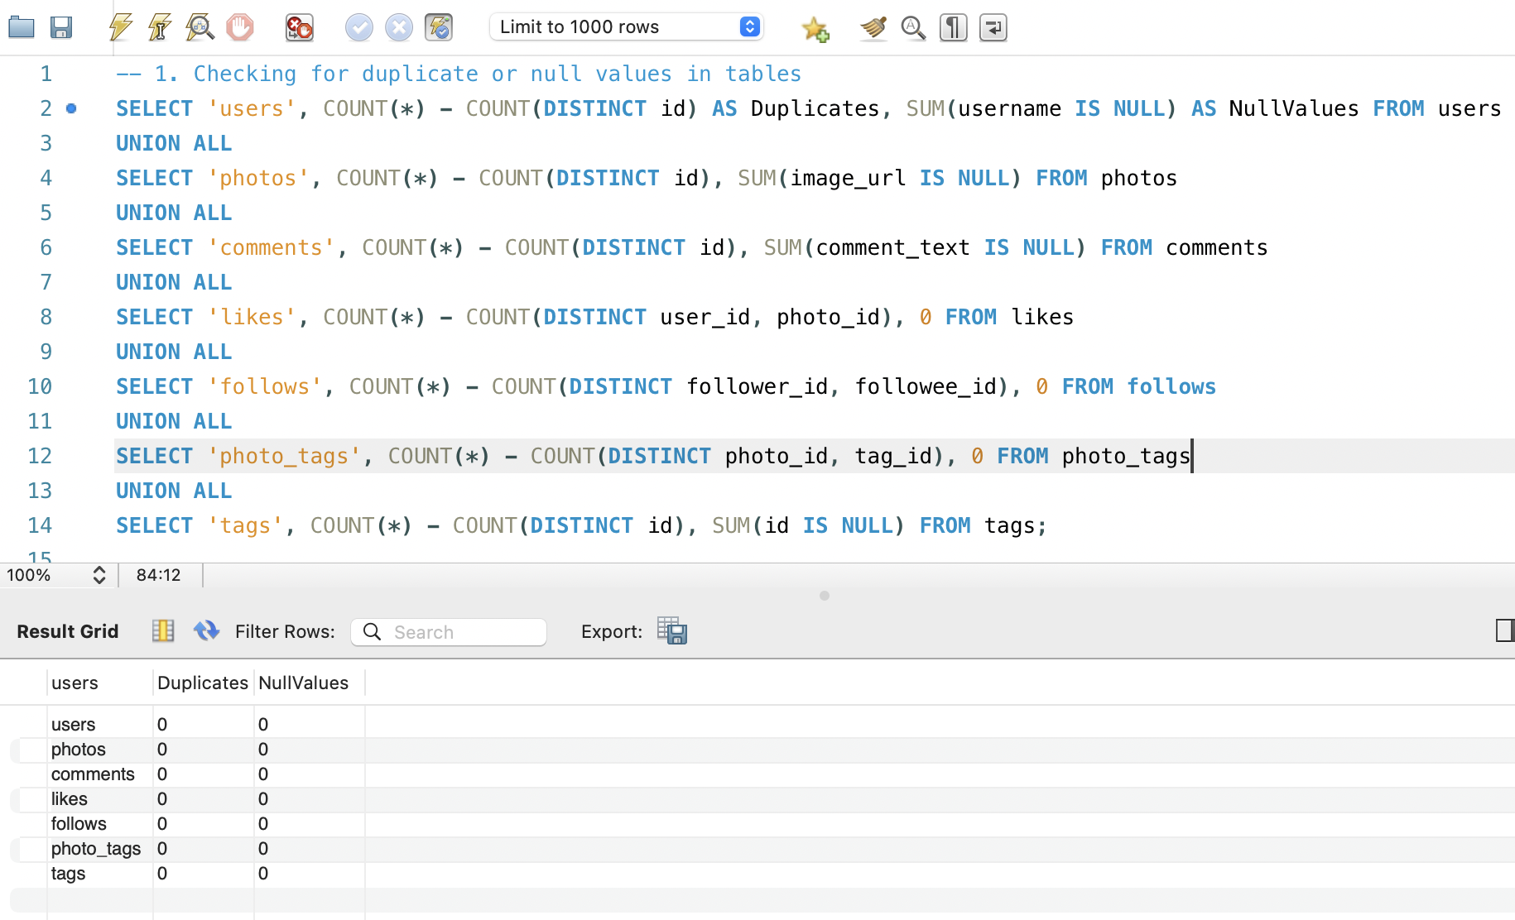

1. **What is the distribution of user activity levels (e.g., number of posts, likes, comments) across the user base?**

This query counts posts, likes, and comments per user using COUNT(DISTINCT column), including those with no posts, likes, or comments. A "LEFT JOIN" is used to connect the likes, comments, and photos tables with the users table.

This categorizes users based on activity level.  
  
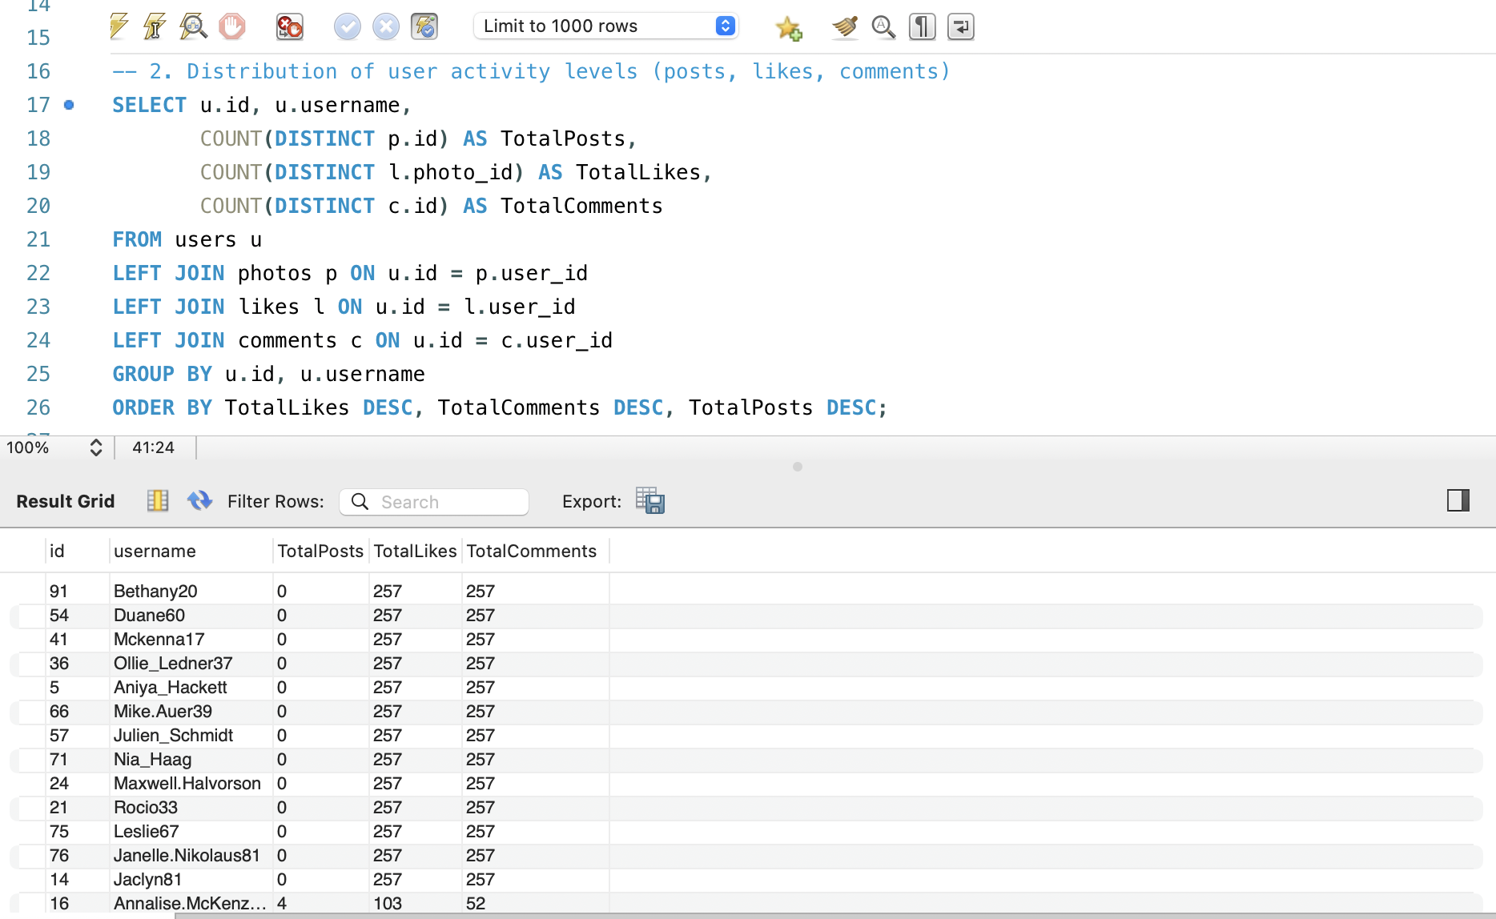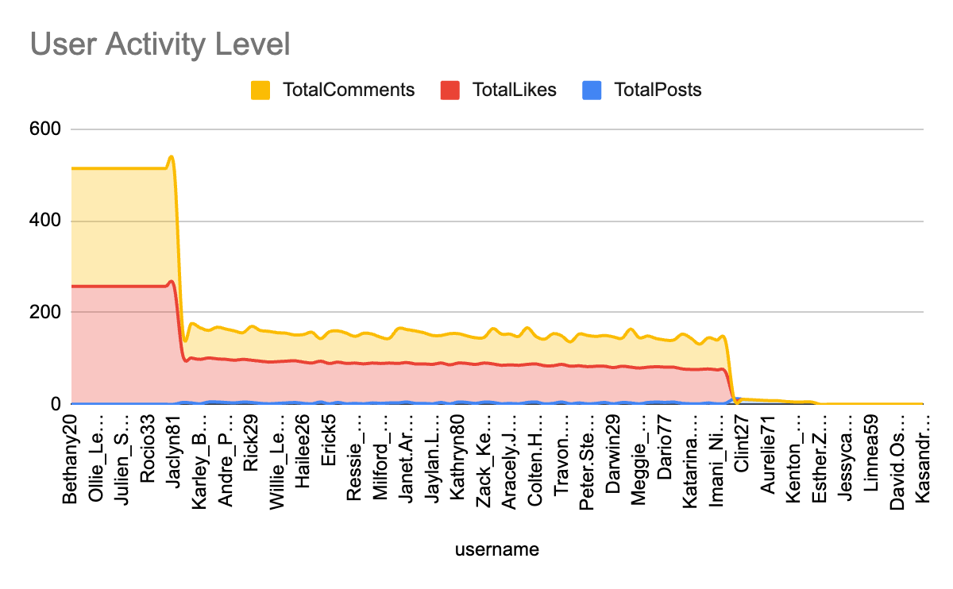

1. **Calculate the average number of tags per post (photo_tags and photos tables).**

This query first calculates the count of tags for each photo in a subquery and then computes AVG(tag_count) as AvgTagsPerPost.

The calculated average indicates how often users use tags.

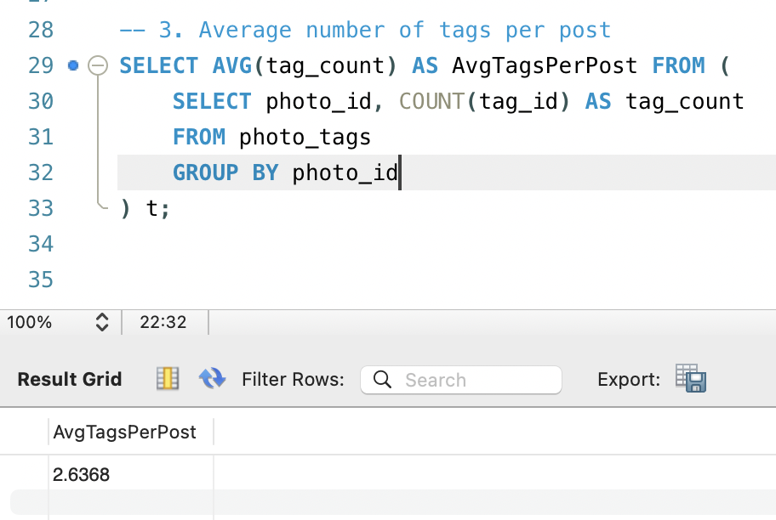

* The output reveals that the average number of tags per post is 3.

1. **Identify the top users with the highest engagement rates (likes, comments) on their posts and rank them.**

Here**,** user engagement is calculated by summing likes and comments per user and ranking them using ORDER BY Engagement DESC, considering only users who have posted at least one photo. A "LEFT JOIN" is employed to connect the users table with the other relevant tables.

This identifies the top 10 most engaging users based on likes and comments.

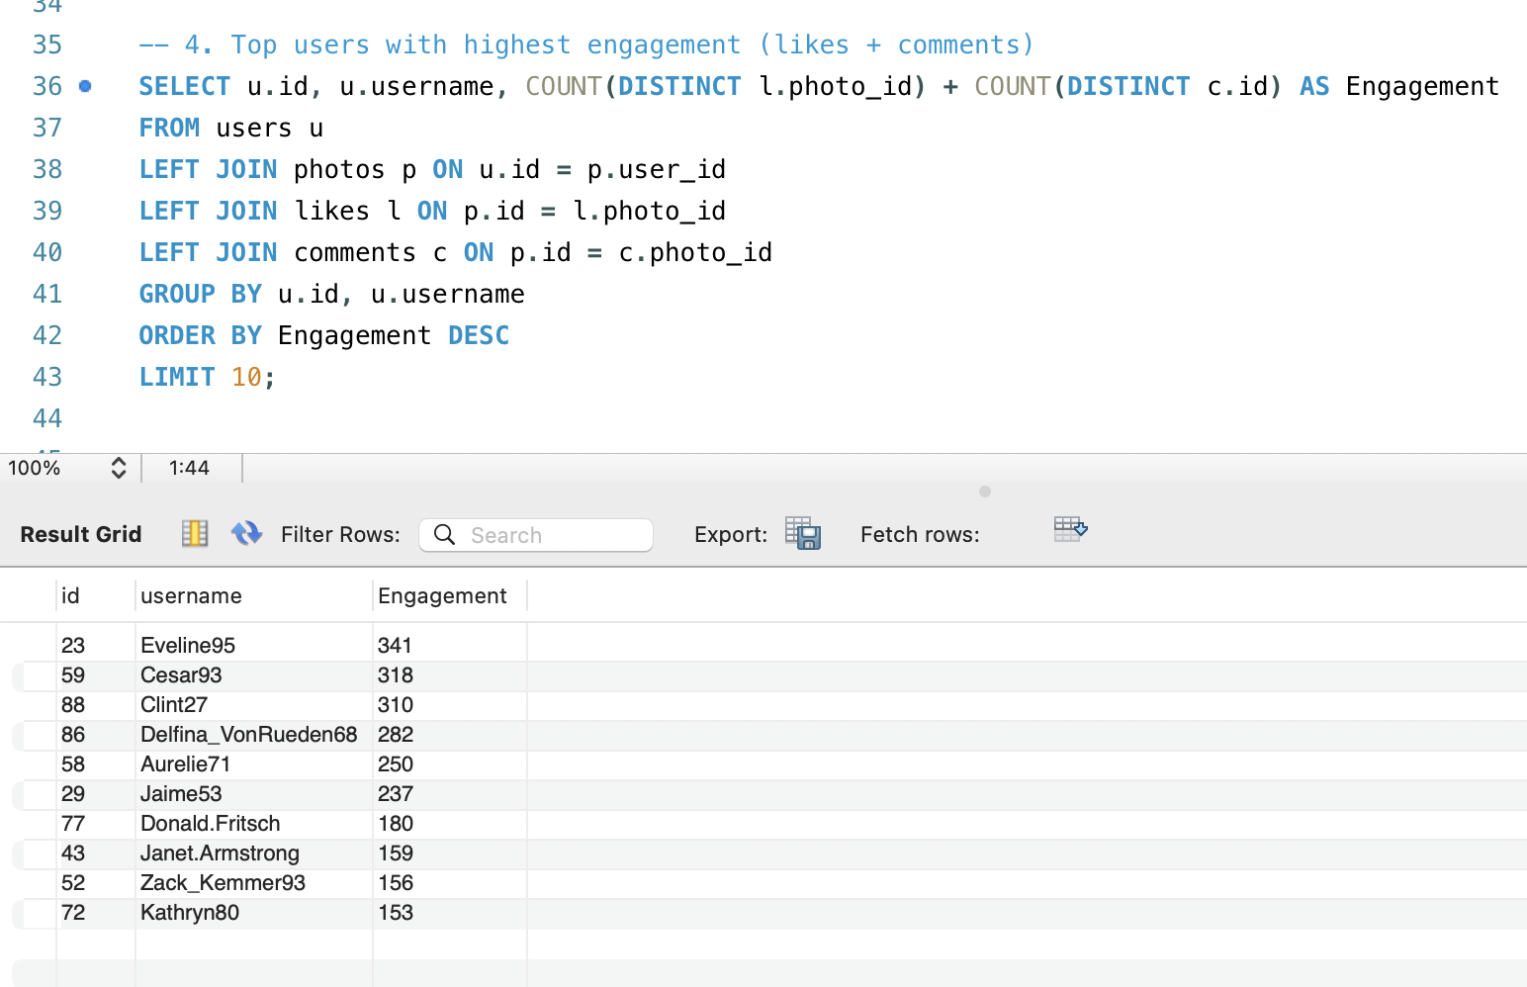

1. **Which users have the highest number of followers and followings?**

This query retrieves the user's ID, username, and their follower or following count. Used COUNT(follower_id) to find the most-followed and most-following users.

Highlights networking trends. The "LIMIT" clause is used to return only the first user in the specified order.

This provides details of the most-followed and most-following users which helps in understanding user influence and networking trends.

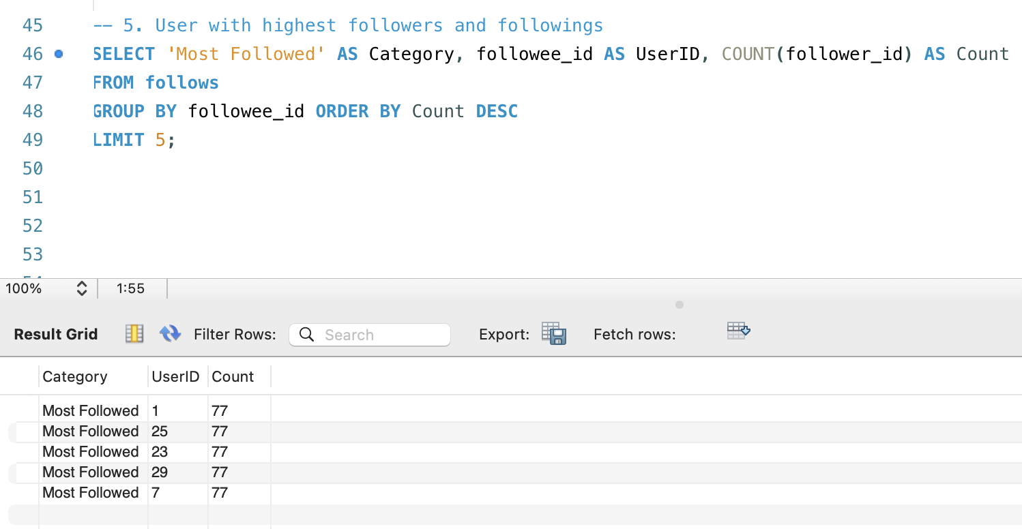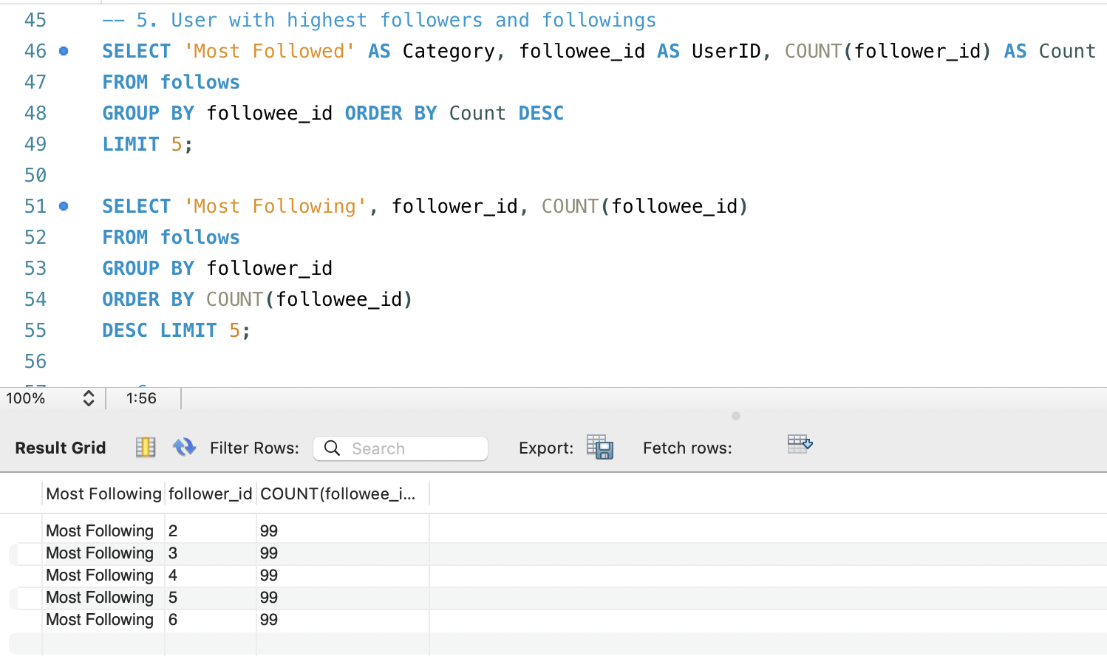

1. **Calculate the average engagement rate (likes, comments) per post for each user.**

It retrieves the user ID, username, and engagement rate for users who have made at least one post. We used AVG(likes + comments) per post. This shows how well posts are performing on average.

The main purpose is to evaluate content performance.

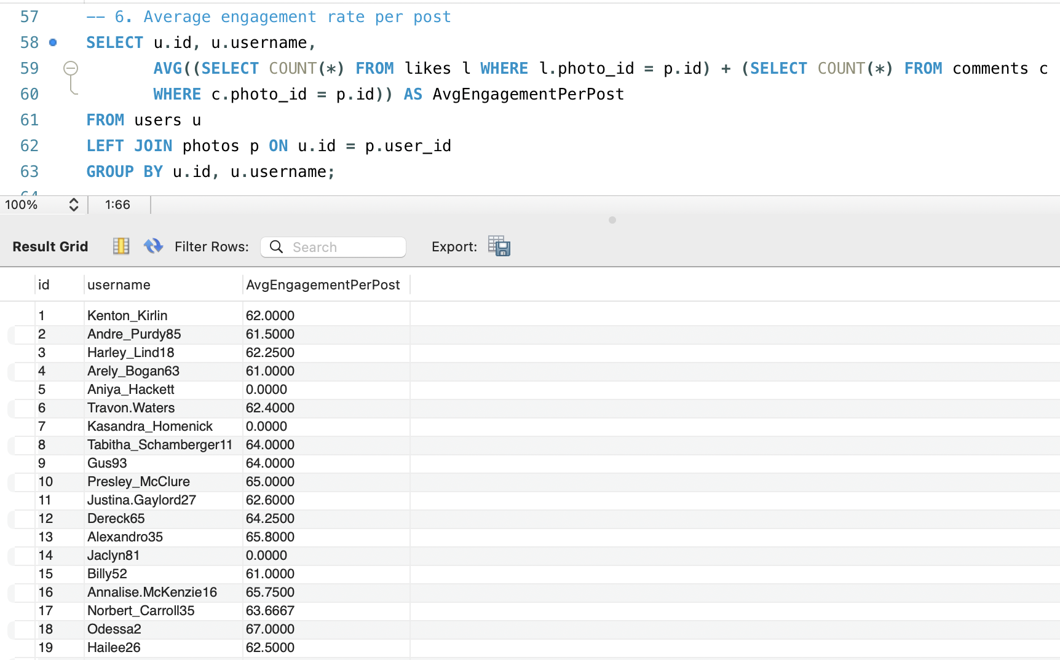

1. **Get the list of users who have never liked any post (users and likes tables)**

This query retrieves the ID and username of users whose IDs are not

present in the likes table. Used LEFT JOIN likes and filtered WHERE l.user_id

IS NULL. This is the list of users who haven’t interacted with posts via likes.

This identifies inactive users for engagement strategies.  
  
 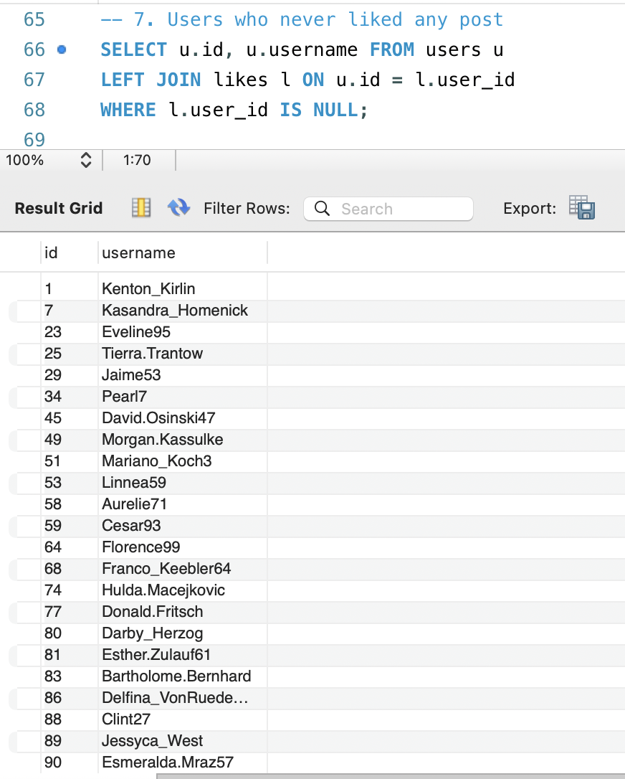

1. **How can you leverage user-generated content (posts, hashtags, photo tags) to create more personalized and engaging ad campaigns?**

Here,We counted hashtag usage and ranked the top 10 using ORDER BY UsageCount DESC. That is the top 10 hashtags based on usage count. Basically, this query calculates the average number of likes for photos associated with each tag. It starts by determining the total likes per photo and then averages these totals across all photos linked to each tag. The results are grouped by tag name and sorted in descending order of average likes. Finally, the top 10 tags with the highest average likes are selected and displayed.

This helps in targeted advertising.

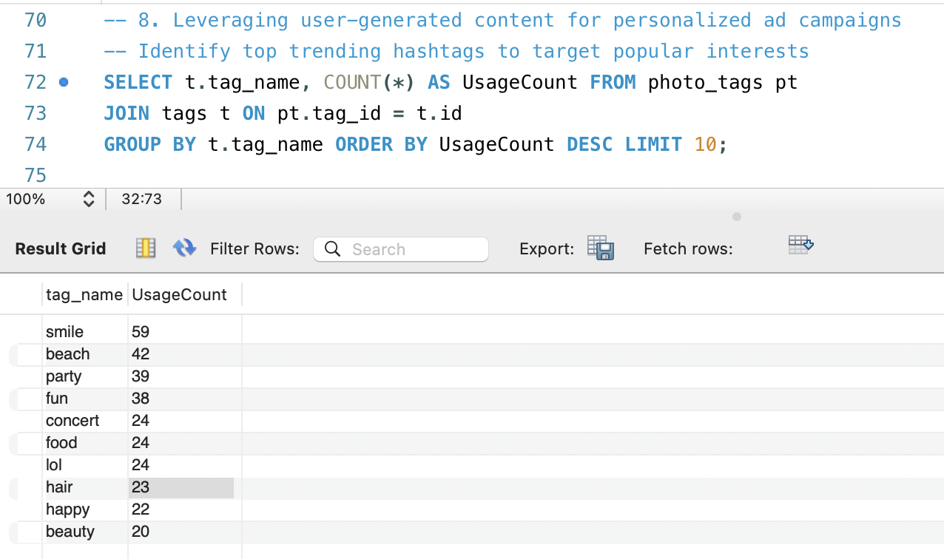  
  
This query determines the frequency of each tag used in photos by joining the tags and photo_tags tables, linking tags with their respective photos. It then groups the results by tag name to calculate the total usage count for each tag. To highlight the most commonly used tags, the query sorts them in descending order based on their frequency. The final output presents each tag's name along with the number of times it has been used.

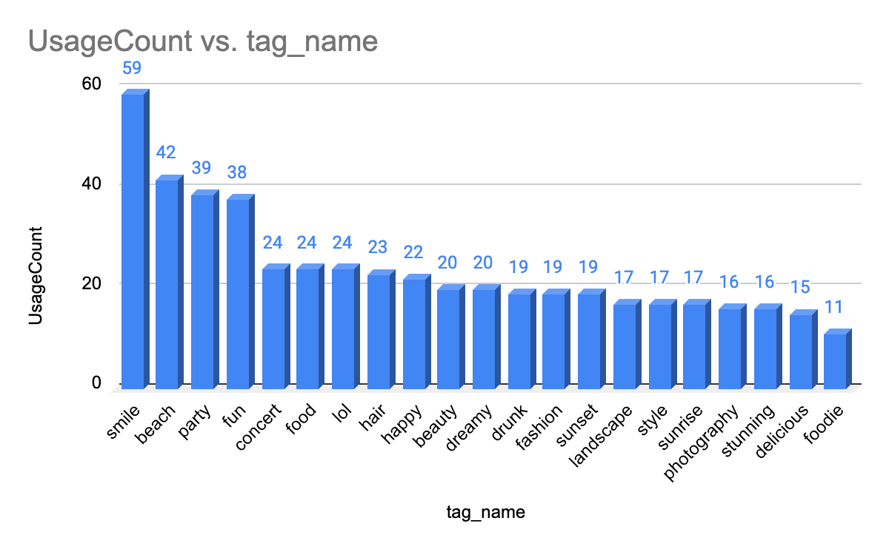

1. **Are there any correlations between user activity levels and specific content types (e.g., photos, videos, reels)? How can this information guide content creation and curation strategies?**

Firstwe havecounted likes and comments for each image and created a Total Engagement metric (likes + comments). Then Added a Like-to-Comment Ratio (Likes / Comments) to measure user interaction trends and Ordered results by Total Engagement DESC to find the most engaging content. This Identifies the most liked and commented images.

So, there is no correlation between user activity levels and specific content types.

This Helps content creators optimize post types for maximum engagement and Businesses can target highly interactive content for promotions.  
  
Users tend to focus on one type of engagement, either commenting or posting photos.

The majority prefer photos as their primary content type, making photo-sharing a significant driver of user engagement on the platform.

**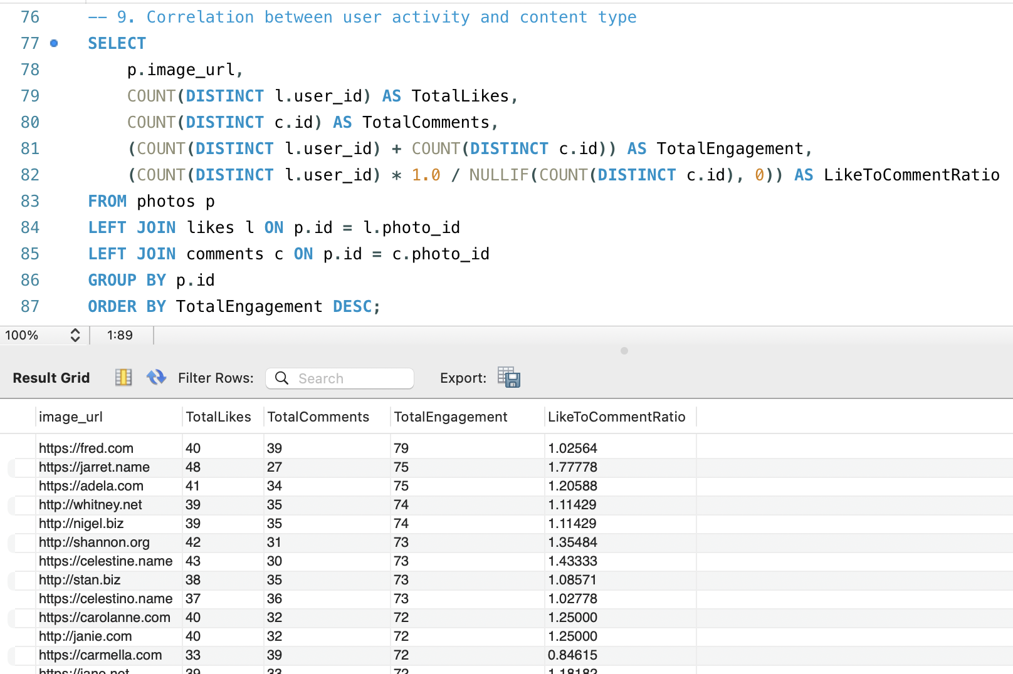  
  
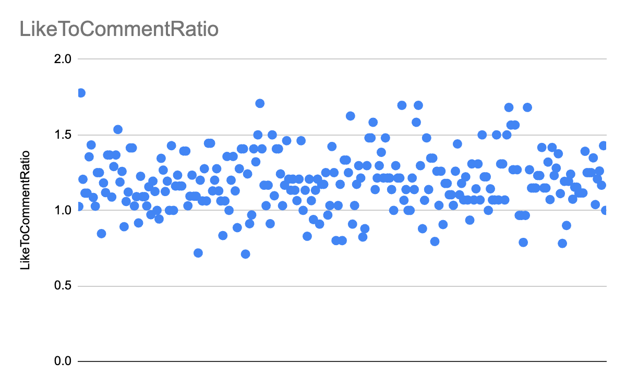**

1. **Calculate the total number of likes, comments, and photo tags for each user.** This query **COUNT(DISTINCT column)** aggregates the total likes, comments, and photo tags for each user on the platform, combining these figures with user details. It ensures that users with no activity are still represented, with their counts set to zero

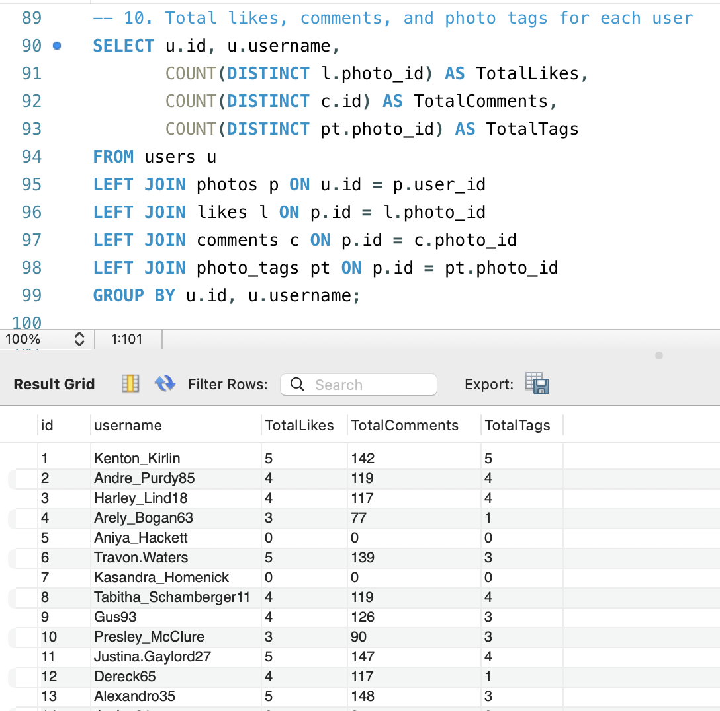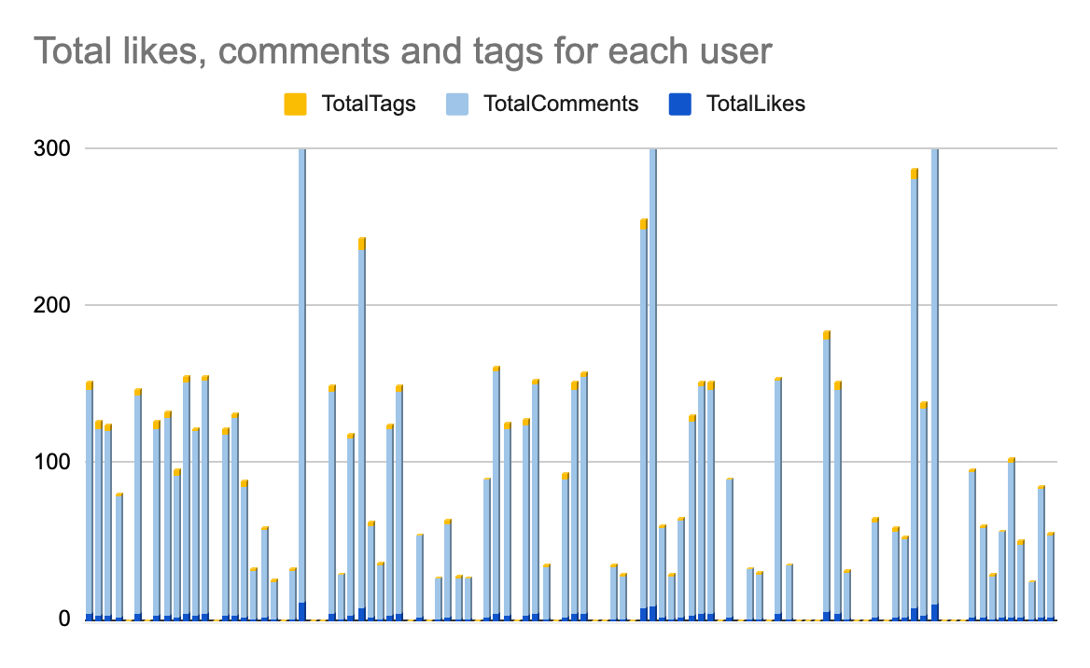

1. **Rank users based on their total engagement (likes, comments, shares) over a month.**

This query calculates and ranks user engagement for the past month by aggregating the total likes, comments, and tags associated with each user's photos. It sums these values to determine a total engagement score and ranks users accordingly, with the highest engagement ranked first. The output includes each user's ID, username, total engagement and their engagement rank.

This helps track user retention and engagement trends.

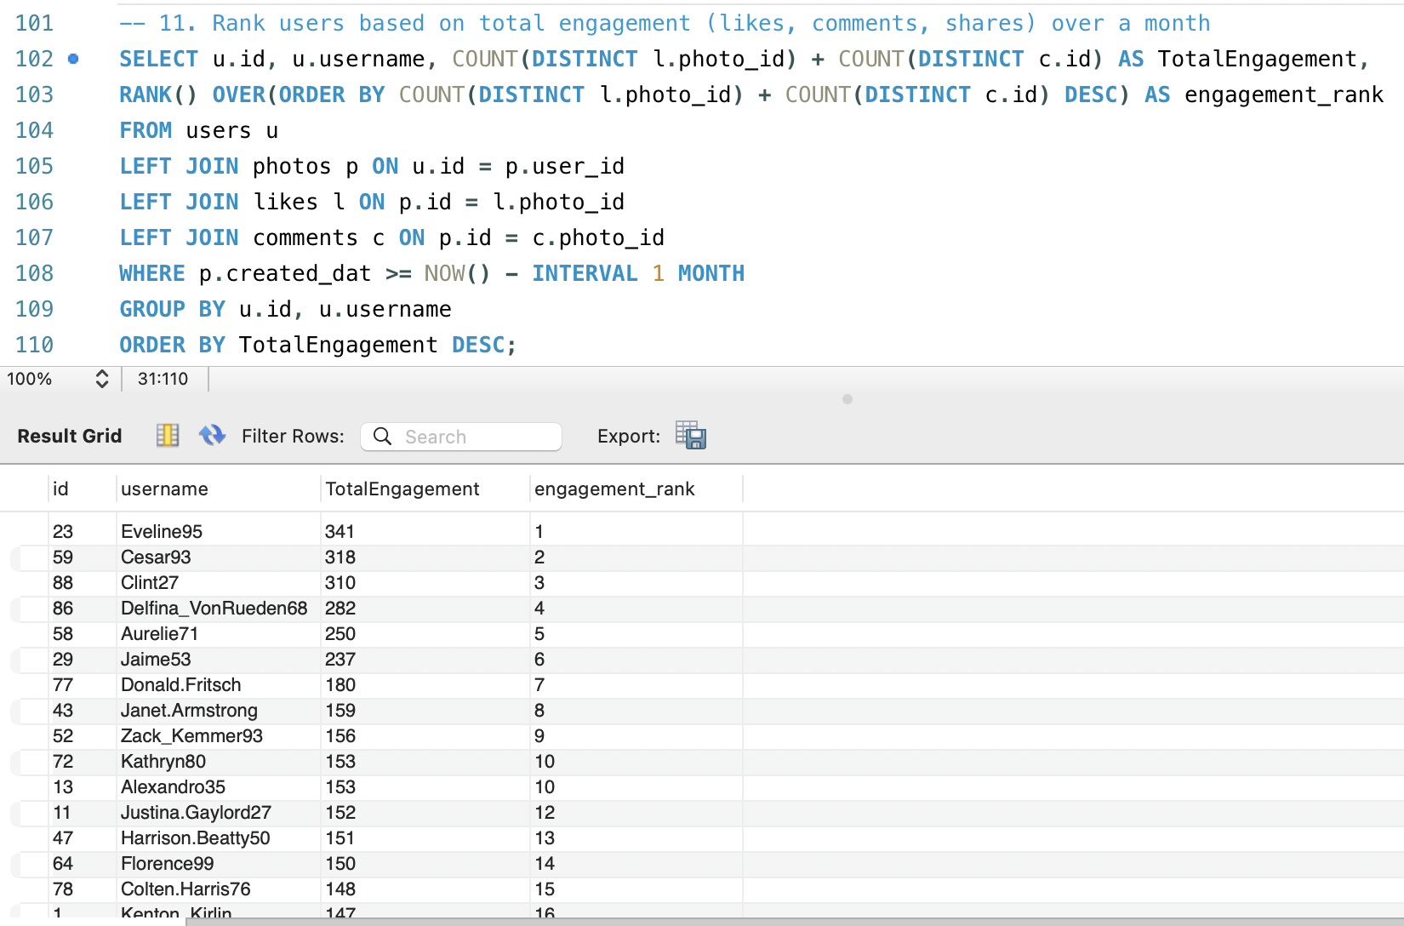

1. **Retrieve the hashtags that have been used in posts with the highest average number of likes. Use a CTE to calculate the average likes for each hashtag first.**

This query calculates the average likes for photos associated with each tag. It begins by summing the likes for each photo and then averages these totals across all photos linked to each tag, where we use AVG(likes) for each hashtag. The results are grouped by tag name and sorted by average likes in descending order. Finally, the top 10 tags with the highest average likes are displayed.

This finds the most engaging hashtags.

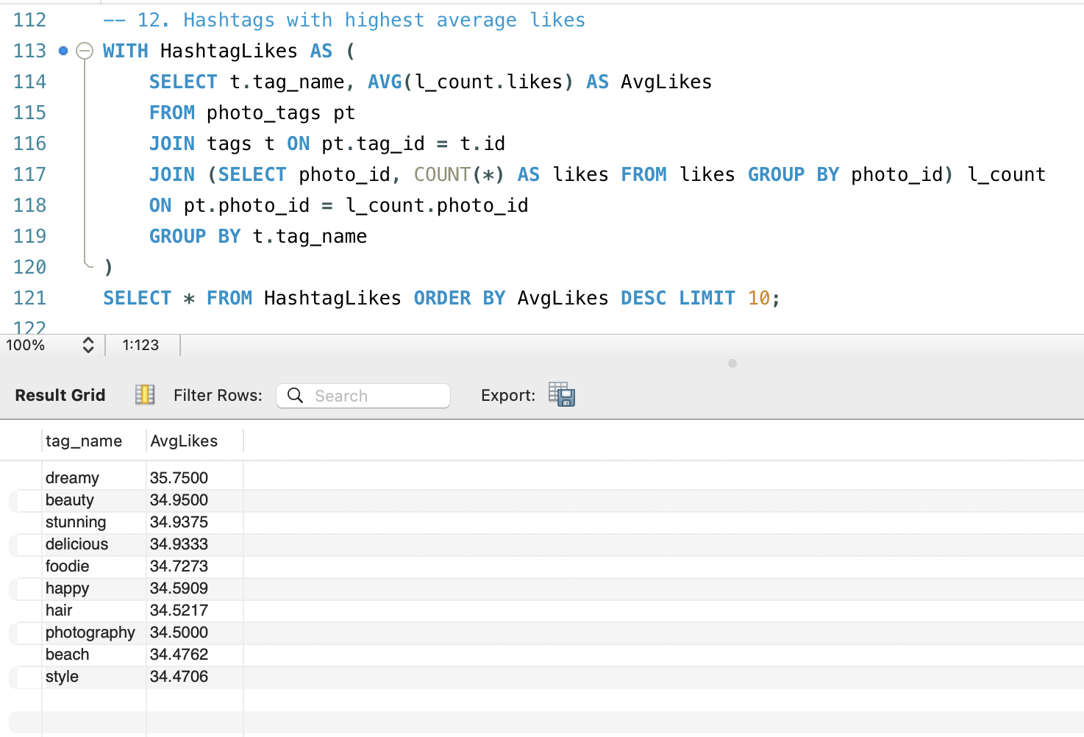

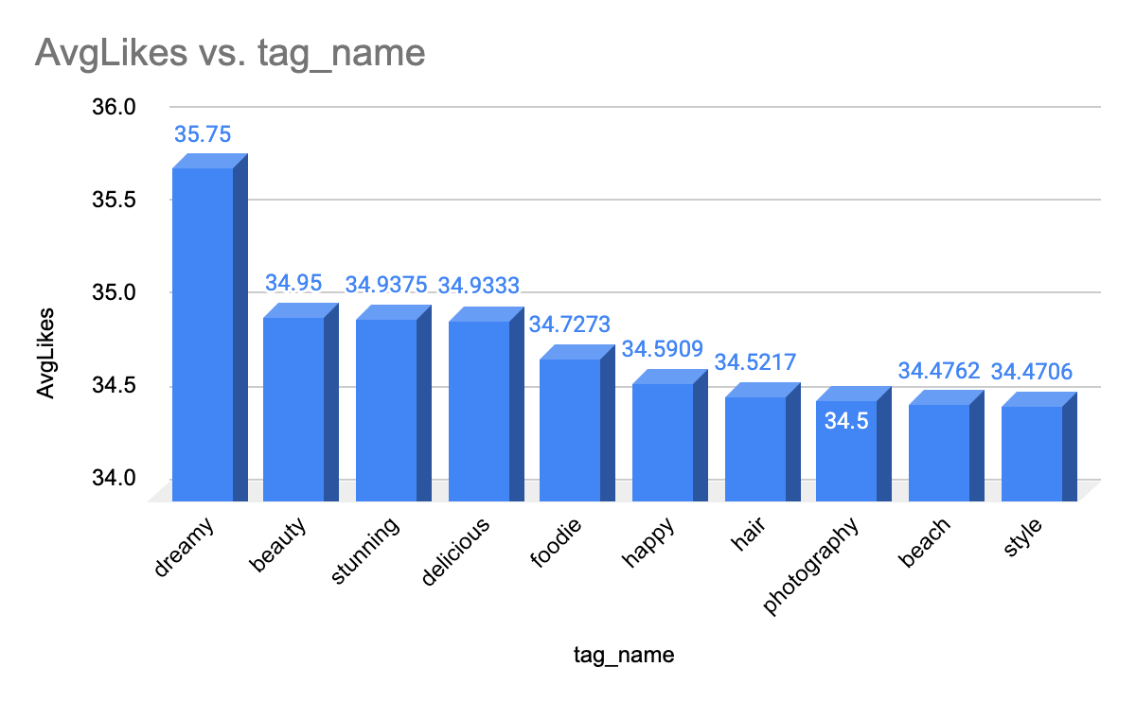

1. **Retrieve the users who have started following someone after being followed by that person.**

This query identifies pairs of users who follow each other, where one user followed the other first. It matches users based on their follow relationships and used JOIN follows to match mutual follows.

It is useful for social behavior analysis and community building and analyzes follow-back behavior.

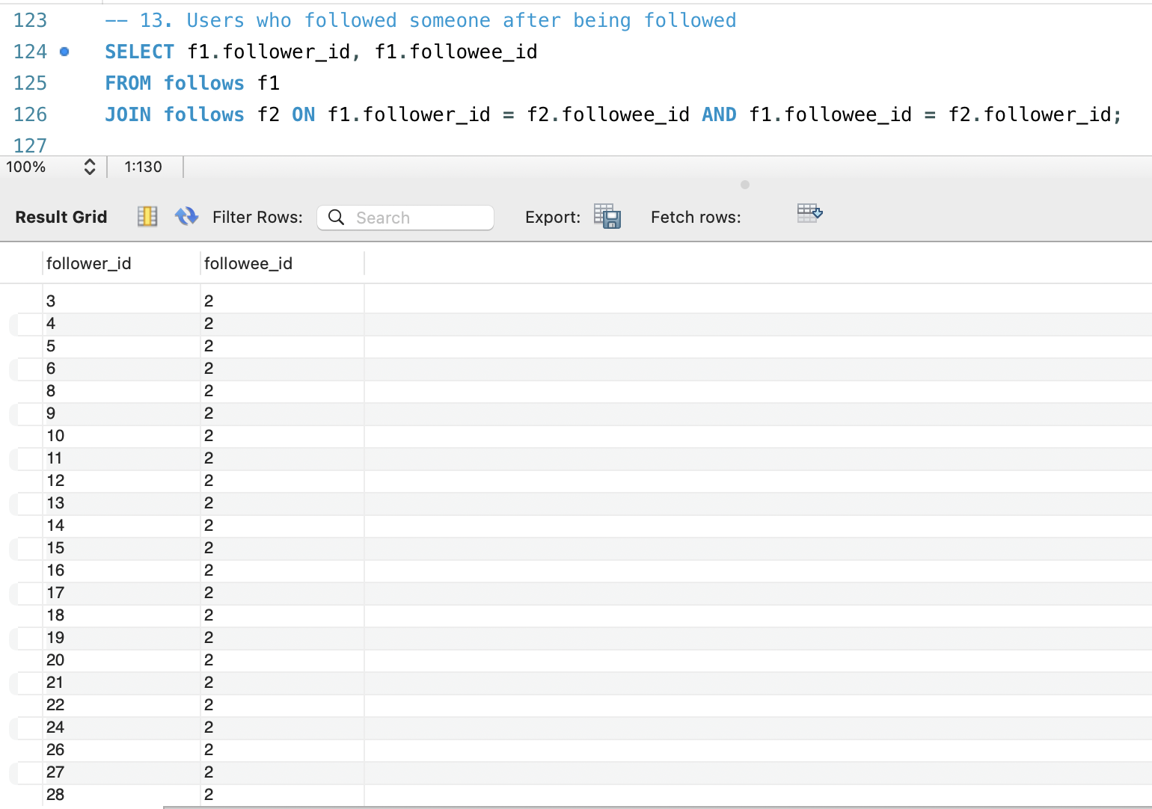

**Subjective Questions**:

1. **Based on user engagement and activity levels, which users would you consider the most loyal or valuable? How would you reward or incentivize these users?**

This query evaluates and ranks users based on their overall engagement on the platform. It combines several activity metrics, such as the number of photos posted, comments made, likes given, followers, and following count, to compute an engagement_score for each user. Users are ranked in descending order of their engagement score. The output includes the user ID, username, engagement score, and rank, showing only the top-ranked user with the highest engagement score.

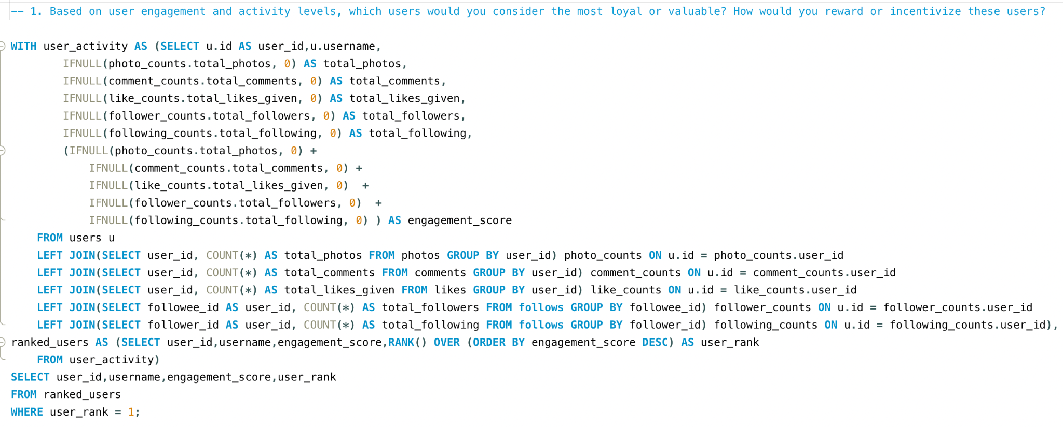

Output

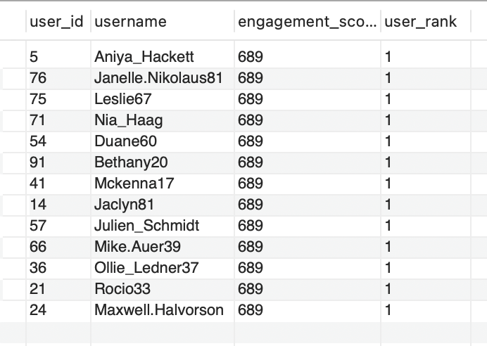

* The most loyal and valuable users are: Aniya_Hackett, Duane60, Mckenna17, Mike.Auer39, Jaclyn81, Rocio33, Julien_Schmidt, Maxwell.Halvorson, Bethany20, Janelle.Nikolaus81, Leslie67, Ollie_Ledner37, and Nia_Haag.
* This list is determined based on each user's engagement score, which takes into account the total photos uploaded, comments made, likes given, total following, and total followers.

Ways to Reward and Incentivize Users :

* Gift Cards and Discounts  
  Offering gift cards or discounts is a popular and highly effective way to reward valuable users. These incentives encourage users to engage more with the platform by providing exciting and tangible benefits.
* Exclusive Access to Tools or Features  
  Granting access to special tools or features can support valuable users in their growth and simplify their experience. For example, providing engagement insights or analytics can help them better understand their audience and optimize their performance.
* Invitations to Events  
  Inviting users to attend platform-hosted events fosters community connection, helps them expand their network, and builds a stronger bond with the platform.
* Custom Badges or Titles  
  Awarding personalized badges or titles recognizes users' contributions and highlights them within the community, boosting their visibility and sense of achievement.

1. **For inactive users, what strategies would you recommend to re-engage them and encourage them to start posting or engaging again?** This query evaluates and ranks users based on their minimal engagement on the platform. It aggregates various activity metrics, including the number of photos, comments, likes given, followers, and following, into an engagement_score. Users are ranked in ascending order, with the user having the lowest engagement score ranked highest. The output displays the user ID, username, engagement score, and rank, focusing on the user with the lowest engagement score.

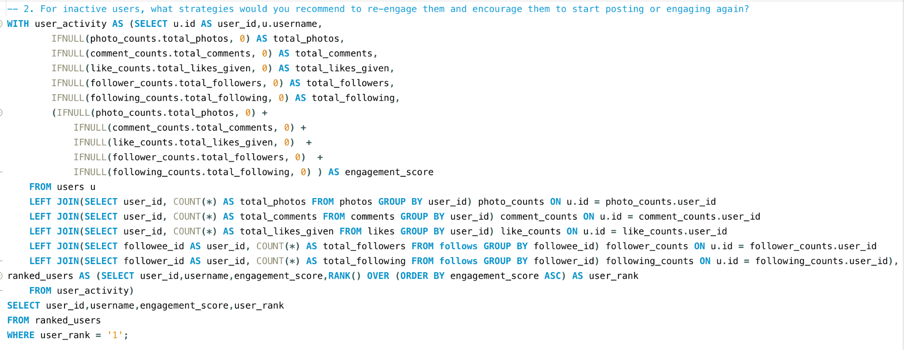Output  
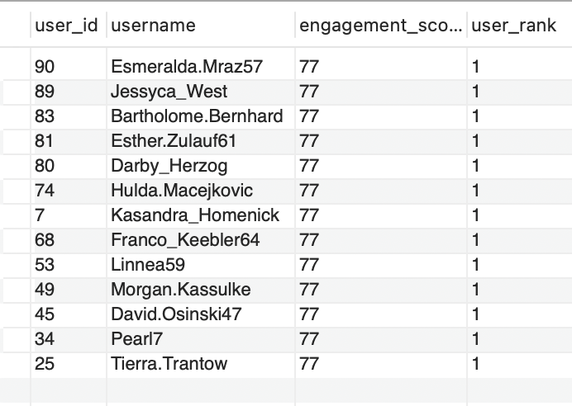  
  
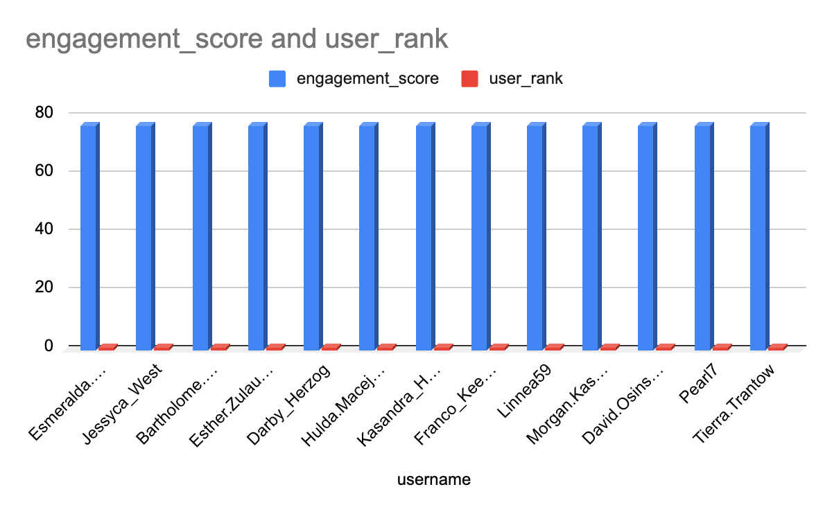

Strategies to Encourage Inactive Users to Start Posting or Engaging Again:

Personalized Re-engagement Outreach:

* Highlight Missed Opportunities: Send customized emails showcasing trending content or updates from their connections they may have missed.
* Tailored Recommendations: Suggest content, groups, or hashtags aligned with their previous activity and interests.

Targeted In-App Notifications:

* Milestone Reminders: Notify users of milestones they are close to achieving, such as reaching a specific number of followers or likes, to encourage further engagement.

Incentivize User Participation:

* Gamified Challenges: Introduce contests or activity-based challenges with rewards for the most engaging content or hitting key milestones.

Enhance User Experience:

* Content Creation Assistance: Provide prompts or templates to simplify the process of creating and sharing content, lowering the barrier for engagement.
* Re-Onboarding Walkthroughs: Offer a refreshed onboarding experience to reacquaint users with platform features and benefits they might not have explored.

Engagement-Centric Campaigns:

* Themed Events and Weeks: Host virtual events or themed content weeks to inspire participation and foster engagement.

Feedback and Improvement:

* Surveys and Feedback Loops: Reach out to inactive users for feedback on their experience. Use their insights to address concerns and offer tailored solutions.

Enhanced Content Discovery:

* Improved Explore Pages: Curate personalized explore pages that highlight trending and relevant content aligned with users' previous preferences to spark renewed interest.

1. **Which hashtags or content topics have the highest engagement rates? How can this information guide content strategy and ad campaigns?** This query identifies the top 10 tags with the highest average engagement on the platform. It computes the total posts, likes, and comments for each tag, then calculates the average engagement per post. The results are sorted in descending order of average engagement.

The hashtags with the highest engagement rates are: delicious, beauty, foodie, sunset, stunning, food, photography, dreamy, smile, and party.

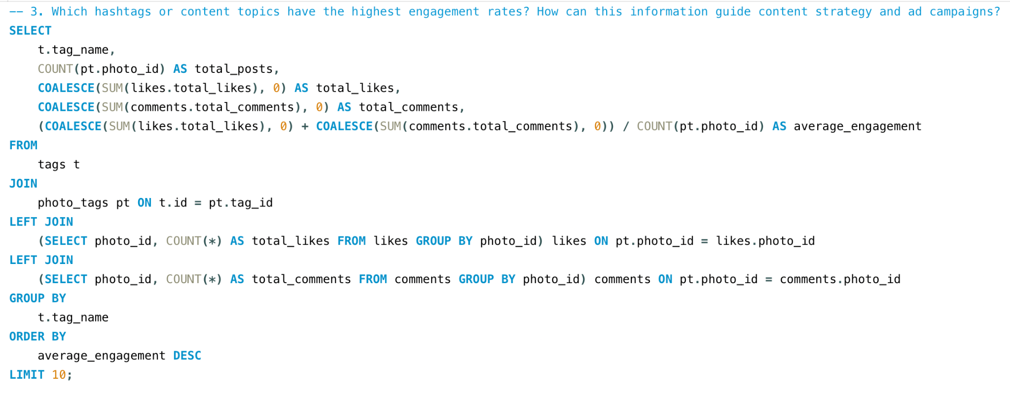

Output

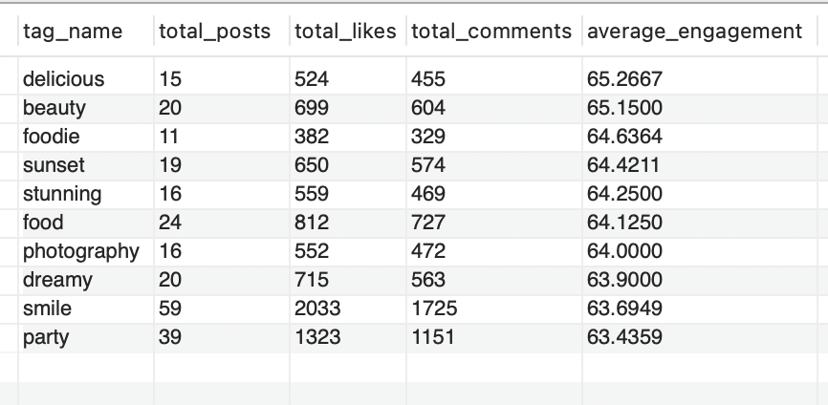

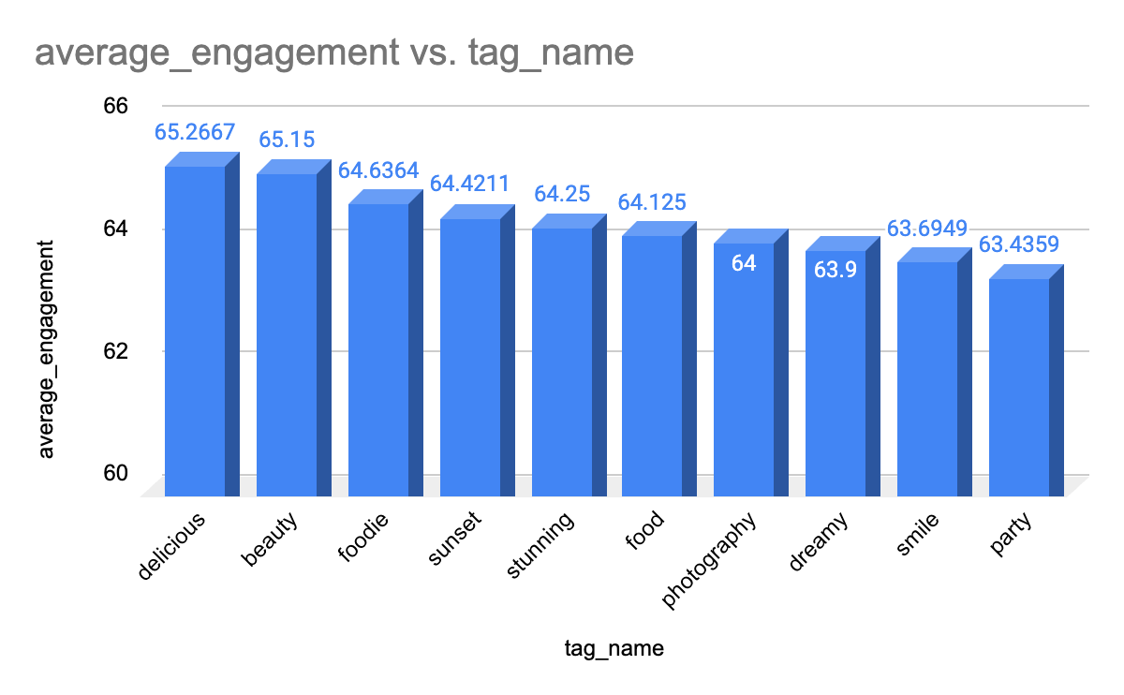

Content Creation and Curation:

* Prioritize content that aligns with these high-engagement themes. For example, posts related to food (#delicious, #food, #foodie), beauty (#beauty, #stunning), and photography (#photography, #sunset) can attract significant attention.
* Encourage users to create content featuring these hashtags. For instance, launch campaigns inviting users to share their favorite #sunset or #foodie moments to increase engagement.

Ad Targeting and Campaigns:

* Ad Copy and Creative: Integrate these hashtags into ad copy and visuals. For example, an ad promoting a product can highlight how it fits into the #beauty or #foodie lifestyle.
* Influencer Collaborations: Collaborate with influencers who actively use these hashtags and achieve high engagement. Partnering with food influencers under #delicious or #foodie can help drive targeted engagement.
* Hashtag-Based Targeting: Target ads to users who have interacted with content related to these hashtags, ensuring ads reach an audience already interested in these themes.

Engagement Optimization:

* Trending Content Series: Create a recurring content series based on these hashtags. For example, a weekly #sunset or #party post can keep followers engaged and anticipate new updates.
* Cross-Promotion: Share posts featuring these hashtags across various social platforms to drive traffic and engagement back to Instagram.
* Optimal Timing and Frequency: Analyze the best times and posting frequency for content with these hashtags. For instance, sharing #sunset content during evening hours can maximize visibility and engagement.

Content Discovery and Algorithm Boost:

* Hashtag Usage for Algorithm Boost: Regularly include these high-engagement hashtags in posts to improve their visibility and performance in the algorithm. Trending hashtags increase the likelihood of appearing on the Explore page, extending reach.
* Tailored Recommendations: Leverage insights from these hashtags to customize content recommendations for users, enhancing their experience and driving greater engagement.

1. **Are there any patterns or trends in user engagement based on demographics (age, location, gender) or posting times? How can these insights inform targeted marketing campaigns?** This query analyzes photo engagement based on the hour of the day and day of the week. It groups photos by the hour they were posted, counting the total number of posts, likes, and comments for each hour. The average engagement per post (calculated as likes plus comments divided by the number of posts) is then computed and the results are sorted in descending order by this average engagement.  
     
   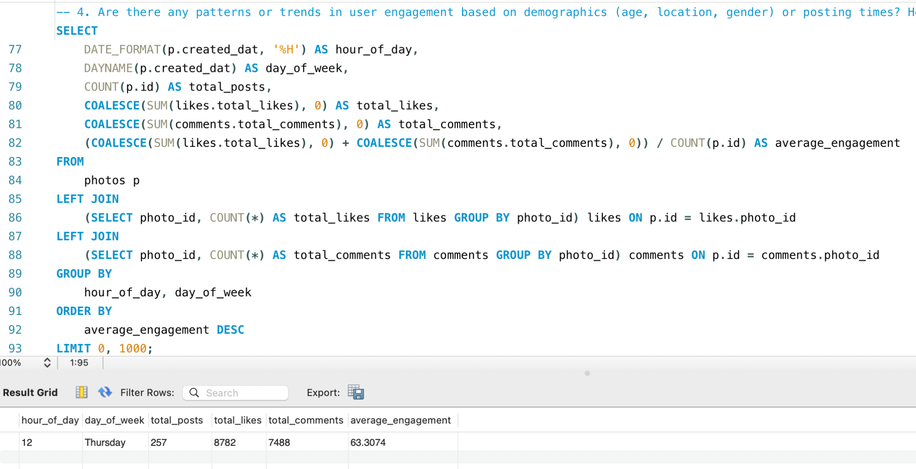

* The output above reveals that the highest user engagement occurs at 12 AM on Thursdays, with an average engagement of 63.3.
* With a total of 257 posts, 8,782 likes, and 7,488 comments, the average engagement rate for approximately 100 users who predominantly post at 10 AM on Tuesdays has been calculated.
* Based on this analysis, since user engagement is highest during this specific time and day, this pattern can be leveraged for targeted ad marketing.
* Clear patterns and trends in user engagement emerge based on demographics. For instance, posts featuring sunsets, reels, and videos with hashtags like #sunset, #evening, and #photography will gain more reach when posted in the evening, as the content will resonate better with users at that time.
* Additionally, age and gender play a significant role, as different age groups are attracted to and engage with varying types of content.

1. **Based on follower counts and engagement rates, which users would be ideal candidates for influencer marketing campaigns? How would you approach and collaborate with these influencers?** This query ranks users based on their engagement rate. It calculates each user's follower count and aggregates the total likes and comments on their photos. The engagement rate is determined by dividing the total engagement by the number of followers, with a special condition to handle cases where users have no followers. The results are sorted in descending order of engagement rate, with ties resolved based on follower count. The query returns the top 10 users with the highest engagement rates, including their user ID, username, follower count, total likes, total comments, total engagement, and engagement rate.

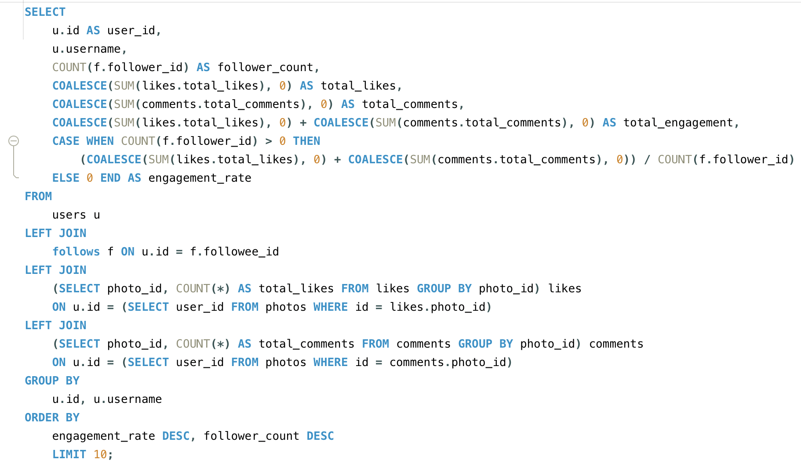

Output

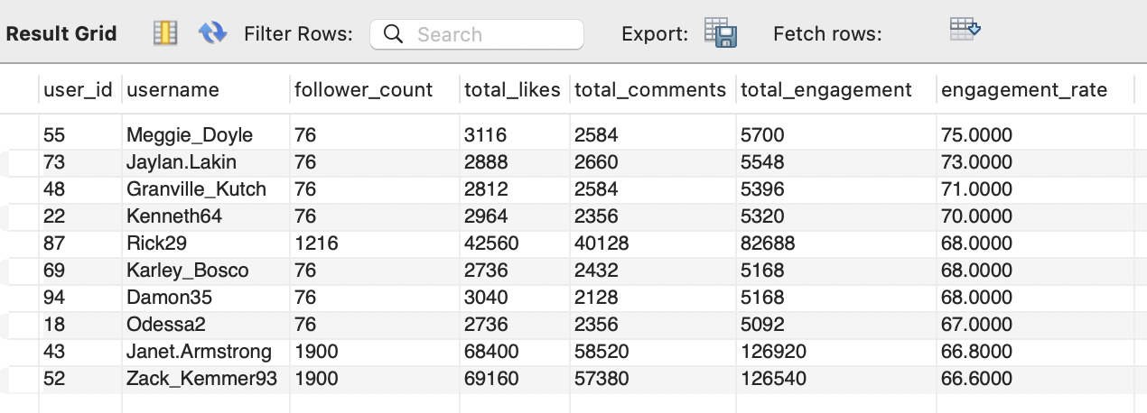

Approaching and Collaborating with Influencers:

Research and Personalization:

* Analyze the influencer's content and audience to ensure alignment with your brand.
* Tailor your outreach by referencing specific posts or campaigns that resonate with your brand's values.

Collaboration Strategy:

* Establish clear campaign objectives to guide the partnership.
* Allow creative flexibility within defined content guidelines to preserve authenticity.

Compensation and Incentives:

* Offer appropriate monetary compensation or product gifts as rewards.
* Explore long-term collaborations to foster sustained engagement.

Tracking and Amplification:

* Define key performance indicators (KPIs) to evaluate campaign success.
* Share and promote influencer-created content across your brand's platforms to maximize visibility.

1. **Based on user behavior and engagement data, how would you segment the user base for targeted marketing campaigns or personalized recommendations?**  This SQL query analyzes and categorizes user engagement on the platform. It begins by retrieving user details, such as user_id and username, from the users table. By joining the likes and comments tables, it aggregates the total likes and comments for each user. Additionally, it calculates the number of photos each user has posted by referencing the photos table.

* The engagement rate is computed as the total likes and comments divided by the number of photos.
* Users are then classified into engagement levels- 'High,' 'Medium,' or 'Low’ based on their engagement.  
    
  The query groups data by user, organizes the results by engagement rate in descending order, and provides valuable insights into user activity, enabling the identification of varying levels of engagement among users.

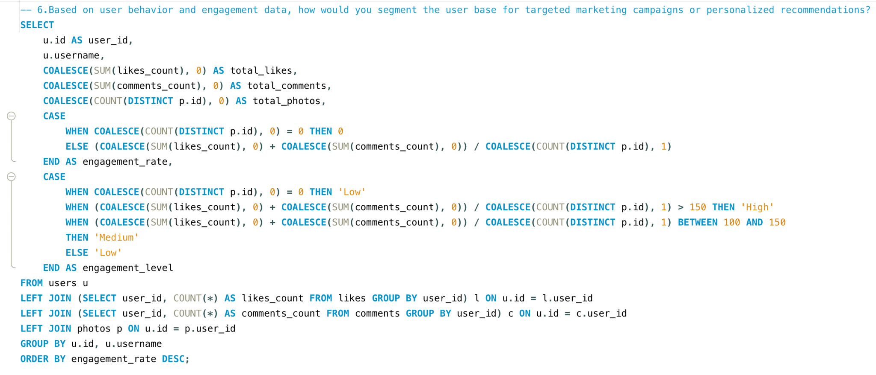

Output

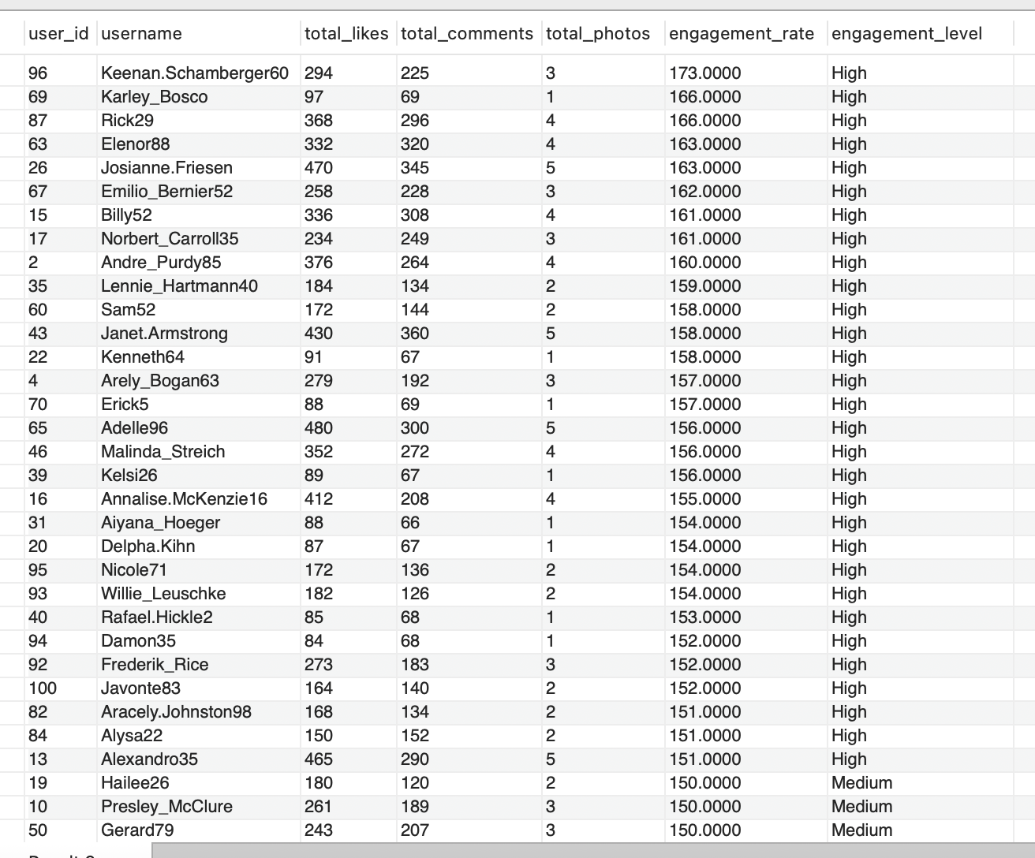

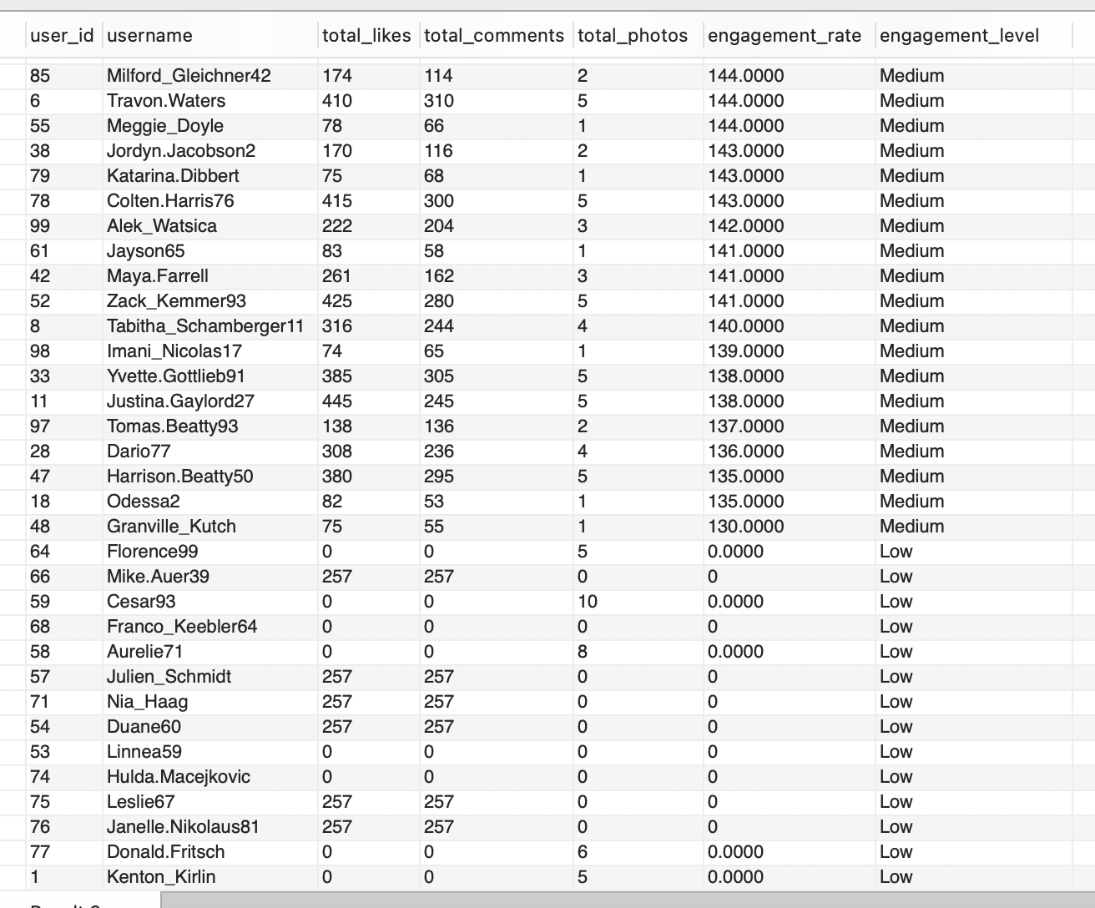

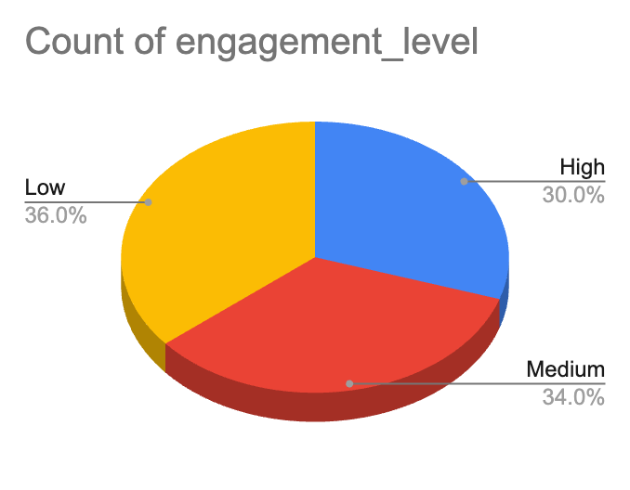

* 30% of the users are high engagement users i.e, 30 out of total 100 users are highly engaged.
* 34% of the users are medium engagement users i.e, 34 out of total 100 users are medium- engaged.
* 36% of the users are low engagement users i.e, 36 out of total 100 users are low- engaged.  
  Strategies for Targeted Marketing and Personalized Recommendations:

High Engagement Users:

* + Marketing Campaigns: Offer exclusive deals or early access to new products. Highlight premium features or products that align with their interests and activity patterns.
  + Personalized Recommendations: Suggest content, products, or services similar to what they frequently engage with. Tailor notifications and updates based on their preferences and past interactions.

Medium Engagement Users:

* + Marketing Campaigns: Run targeted ads to encourage more engagement, such as special promotions or interactive content. Offer incentives like limited-time discounts to drive higher interaction.
  + Personalized Recommendations: Recommend content or products that align with their past behavior but introduce new or trending options to spark more engagement.

Low Engagement Users:

* + Marketing Campaigns: Focus on re-engagement strategies. Offer discounts, reminders, or educational content to reignite their interest. Consider using win-back campaigns with personalized messages.
  + Personalized Recommendations: Introduce them to popular or engaging content and products. Use prompts or curated suggestions to capture their attention and encourage more interaction.

Implementation Steps:

* Data Analysis: Continuously analyze user behavior and engagement metrics to refine segmentation and keep track of evolving trends.
* Custom Messaging: Develop targeted messages and offers tailored to each segment’s interests and characteristics.
* A/B Testing: Test different approaches within each segment to identify the most effective strategies.
* Monitor and Adjust: Track the success of campaigns and recommendations. Use insights from feedback and results to make adjustments and enhance effectiveness.

By leveraging user behaviour and engagement data, you can design more impactful marketing campaigns and deliver personalized recommendations that resonate with each user segment.

1. **If data on ad campaigns (impressions, clicks, conversions) is available, how would you measure their effectiveness and optimize future campaigns?**Measuring Campaign Effectiveness:

Key Performance Indicators (KPIs):

* + Impressions: Monitor the number of times an ad is shown to users. High impressions with low engagement may indicate the need for better audience targeting.
  + Click-Through Rate (CTR): Calculate CTR by dividing clicks by impressions. A low CTR suggests that the ad's creative or copy might need adjustment.
  + Conversion Rate: Track the percentage of clicks that result in a desired action (e.g., purchase, signup). This reflects how effective the ad is in generating meaningful outcomes.

Return on Ad Spend (ROAS):

* + ROAS Calculation: Calculate ROAS by dividing the revenue generated from the campaign by the cost of the ads. A higher ROAS indicates a more profitable campaign.
  + Customer Acquisition Cost (CAC): Measure the cost of acquiring a new customer through the campaign. Compare CAC with the Customer Lifetime Value (CLV) to evaluate long-term profitability.

Impression Share:

* + Track the percentage of impressions your ad receives compared to the total available impressions. A higher share indicates your ad is displayed more frequently in relevant contexts.
  + Use this data to assess visibility and compare performance against competitors.

Bounce Rate:

* + Measure the percentage of users who click on your ad but leave the landing page without further engagement. A high bounce rate may suggest a mismatch between the ad content and landing page relevance.
  + Optimize landing pages to better align with the expectations set by the ad.

2. Optimizing Future Campaigns:

Ad Creative Optimization:

* + Regularly refresh ad creatives (images, videos, copy) to prevent ad fatigue and sustain user interest.
  + Use insights from top-performing creatives to guide design and messaging for future campaigns.

Budget Allocation:

* + Analyze which campaigns or channels provide the best ROAS and adjust your budget accordingly. Focus more on high-performing ads or audience segments.
  + Adjust bidding strategies (manual vs. automated) to maximize efficiency based on the campaign’s goals.

Frequency Capping:

* + Implement frequency capping to limit the number of times a user sees your ad. This helps prevent ad fatigue and enhances user experience.
  + Test different frequency caps to determine the optimal balance between exposure and engagement.

Landing Page Optimization:

* + Continuously improve landing pages using user behavior data (e.g., heatmaps, session recordings). Focus on fast load times, clear calls-to-action (CTAs), and mobile optimization.
  + Ensure landing page content aligns with the ad message to boost relevance and conversion rates.

Cross-Channel Attribution:

* + Use attribution models (e.g., first-click, last-click, linear) to understand how different channels (e.g., social media, search, display) contribute to conversions.
  + Optimize campaign strategies by investing in the channels that most effectively drive the customer journey.

1. **How can you use user activity data to identify potential brand ambassadors or advocates who could help promote Instagram's initiatives or events?**To identify potential brand ambassadors or advocates:

* High Engagement Users:   
  Look for users who consistently engage with content (e.g., likes, comments, shares) and have a notable presence within specific niches or communities. These users are likely to hold influence within their circles.
* Content Creators:   
  Identify users who regularly produce high-quality, original content that aligns with Instagram’s brand values. These users can naturally advocate for the platform through their creative output.
* Positive Sentiment:   
  Utilize sentiment analysis to spot users who frequently share positive feedback about Instagram and its features. These users are genuine advocates who can authentically promote the brand.
* Frequent Interactions:   
  Track users who engage regularly with Instagram’s official account or discuss Instagram on other platforms. Their ongoing participation and enthusiasm make them ideal candidates for brand advocacy.
* Personalized Outreach:   
  Reach out with a message that emphasizes their influence and how their values align with Instagram’s initiatives.
* Value Proposition:   
  Offer incentives like exclusive access, new features, or rewards for participating in campaigns.

Collaboration:

* Set Clear Expectations:   
  Clearly define campaign goals, the type of content expected, and how they can share their involvement.
* Offer Creative Freedom:   
  Give them the flexibility to create content in their own style to maintain authenticity.
* Long-Term Partnership:   
  Consider building lasting relationships with top-performing ambassadors for ongoing promotion of future campaigns or events.

1. **How would you approach this problem, if the objective and subjective questions weren't given?**Approach

Understanding and Analyzing Data:

* Begin by thoroughly examining the data, as it plays a crucial role in addressing the question at hand. In this case, the dataset includes information for only 100 users, which is somewhat limited.

Identifying Key Metrics:

* Engagement Metrics: Calculate each user's engagement rate by assessing likes, comments, tags, and photos. Also, analyze followers and following counts to identify emerging influencers and creators.
* Retention Metrics: Focus on identifying active users who consistently engage with the platform over various time frames (e.g., weekly, monthly, yearly). Recognizing inactive users will help in designing campaigns and events aimed at re-engaging them by understanding their preferences.
* Acquisition Metrics: Examine the growth of new users and the role that high-engagement users play in attracting these newcomers.

User Segmentation and Targeted Marketing:

* Segment by Engagement Level: Classify users based on their activity level (e.g., highly active, moderately active, inactive). Identify those with a large following and high engagement rates as potential brand ambassadors.
* Personalized Content: Leverage segmentation to deliver tailored content recommendations for different user groups. Target inactive or low-engagement users with re-engagement campaigns, such as reminder emails or in-app notifications.

Analyzing Trends and Their Impact on Engagement:

* Hashtag Analysis: Examine the hashtags used by users, including the most liked and most frequently used ones. This helps understand the topics that attract users and hold their attention on the platform.
* Influencer Identification: Based on the hashtags analyzed, identify potential influencers for each trend. Design campaigns targeting specific user groups associated with these trends.
* Predictive Models: Create models to predict user churn, identify potential influencers, or forecast viral content.
* Example Campaign: Since #smile is a popular hashtag, the marketing team can launch a campaign like #beauty_is_in_smile, encouraging users to post smiling photos using this hashtag along with others like #positivevibes and #happiness. This strategy would boost user engagement and foster growth.

Feedback:

* User Insights:   
  Utilize techniques like click tracking and browsing data to gain deeper insights into user preferences and behavior. This helps tailor content to what users are actively seeking.
* Campaign Feedback:   
  Collect feedback on past campaigns to assess their effectiveness and identify areas for improvement. Use these insights to enhance future campaigns.
* Continuous Improvement:   
  Incorporating feedback is vital to the process, as it allows for the refinement and optimization of ongoing and future initiatives.

1. **Assuming there's a "User_Interactions" table tracking user engagements, how can you update the "Engagement_Type" column to change all instances of "Like" to "Heart" to align with Instagram's terminology?**Query   
     
   UPDATE User_Interactions  
   SET Engagement_Type = 'Heart'  
   WHERE Engagement_Type = 'Like';  
     
   Steps to Implement the Update:

* Verify Data Consistency:   
  Ensure that "Like" is the only term used within the database for engagement types to guarantee a thorough and complete update.
* Implement the Update:   
  Execute the update to replace "Like" with "Heart" in the Engagement_Type column, ensuring consistency across all relevant records.
* Test the Change:   
  Conduct tests in a staging or controlled environment to verify that the update does not negatively impact platform functionality or user experience.
* Notify Users:   
  Inform users about the change in terminology, explaining the reason behind the update and how it may impact their interactions. This can be communicated through in-app messages or public announcements.
* Monitor the Impact:   
  After implementing the update, monitor user interactions and system performance to confirm that the change was applied successfully and that users are adapting to the new terminology.